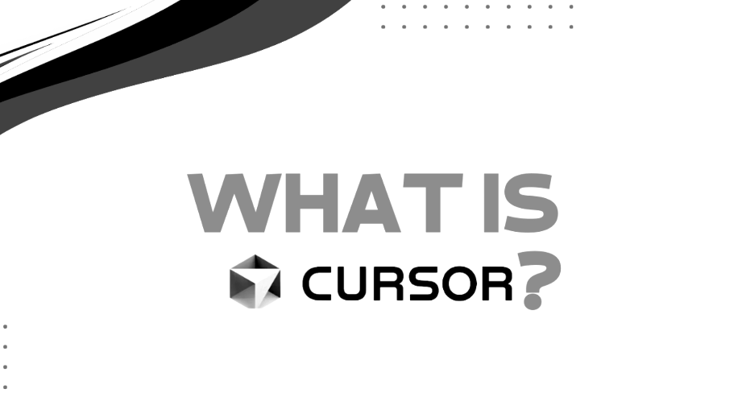

1-Introduction of Cursor

Hi everyone.
Today I want to introduce you to cursor AI, an innovative tool that is revolutionizing the way we write codes as artificial intelligence continues to shape our world.

Cursor AI emerges as a powerful assistant designed to enhance productivity, simplify coding tasks, and support developers in creating more efficient software solutions.

So what exactly is cursor AI?
============================= ==

Built on the top of VS code – familiar environment with extra AI powers.
We can say vs code + ai = Cursor ai.
So vs code is open source it means all the code is on internet, What cursor
People did they took all the code of vs code and apply the ai.

Since Cursor is based on VS Code, developers get a familiar development environment—editor, terminal, extensions, shortcuts, file explorer, etc.—along with additional AI capabilities for coding, understanding the codebase, refactoring, debugging, and generating code.

Unlike traditional code editors, cursor AI provides intelligent code suggestions, automatic bug detection, and even generates complex code structures based on natural language prompts.

This means developers can spend less time debugging and more time focusing on building high quality applications.

2nd => One of the most remarkable features of cursor AI is its ability to understand context Access.

In a normal AI chat, if you ask:
“Fix this function.”
So. the AI may not know how that function is being used elsewhere.

Here, Cursor can use relevant context from your project, such as:
- Current file
- Related files
- Functions and classes
- Imports and dependencies
- Project structure
- Existing implementation
- Error messages
- Your previous instructions/conversation

Simple example
Suppose your FastAPI project has:
blog_app/
│
├── main.py
├── models.py
├── database.py
└── templates/
└── index.html
You tell Cursor:
“Add a delete-post feature.”
Cursor can understand that main.py contains the API/routes, models.py contains the BlogPost model, and the HTML contains the delete button.

So instead of generating an isolated delete_post() function, Cursor can reason about how the feature fits into the existing application.

Whether you are a beginner or experienced developer, this tool can significantly boost your productivity and coding experience.

Alright,
So now let's move on to our next lesson and learn the basics of cursor.
I better.

3rd: Installation of Cursor AI

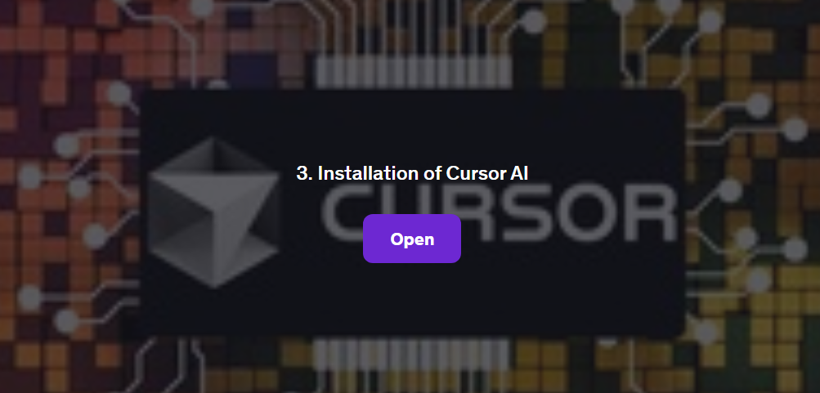

How to Install and Set Up Cursor AI

Cursor AI is an AI-powered coding assistant designed to improve developer productivity.

In this section, we will install Cursor AI and complete the basic setup required to start using it for development.

3.1. Basic prerequisites for Cursor AI

Before installing Cursor AI, ensure you have the following:

Cursor AI — Prerequisites

Hardware
Cursor AI Prerequisites
- Windows 10/11, macOS, or Linux
- 8 GB RAM minimum; 16 GB recommended
- Stable internet connection
- Basic developer environment
Hands-on Project Requirements
- Python 3.11+
- Git
- FastAPI
- Uvicorn
- Chrome/Edge
Optional: MySQL, Postman, pytest — only if required for the hands-on project.

3.2- Installation Steps

1. Download Cursor AI
Go to the official Cursor AI website and download the appropriate version for your operating system.

  - Cursor.com

2. Install Cursor AI

For different OS, follow the installation steps below:

Windows:

- Open the downloaded .exe file.
- Follow the on-screen instructions to complete the installation.

macOS:

- Open the downloaded .dmg file.
- Drag and drop Cursor AI into the Applications folder.

Linux:

- Open the terminal.
- Run the following command:

3.3-Verify Installation

After installation, open a terminal or command prompt and run:

  - cursor –version

If Cursor AI is installed correctly, you should see the version number.

4rth: Set Up Cursor AI

  - Open Cursor AI.
  - Sign in or create an account.
  - Follow the setup wizard to configure your preferences.
  - Integrate Cursor AI with your preferred code editor (VS Code, JetBrains, etc.).

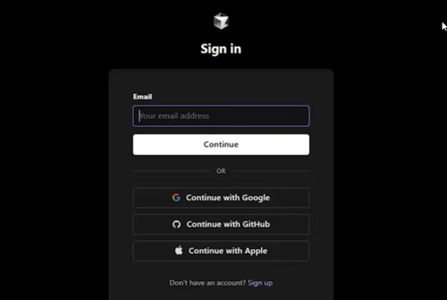

4.1-Test Cursor AI

To ensure everything works, open your code editor and start using Cursor AI for code suggestions and completions.

Conclusion

Congratulations! You have successfully installed and set up Cursor AI. Now, you can enhance your coding experience with AI-powered assistance. Happy coding!

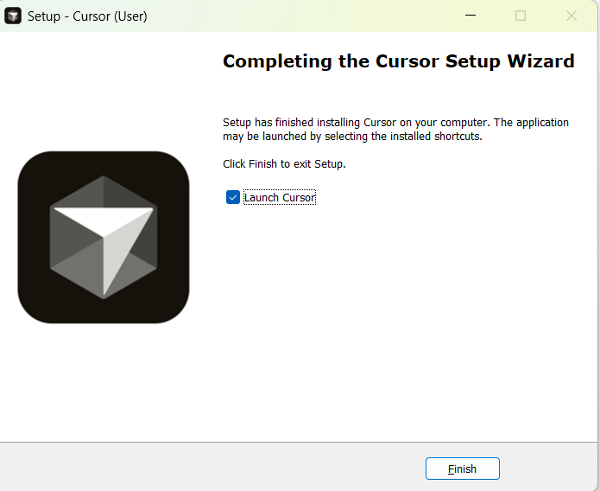

After login it will redirect to this page:
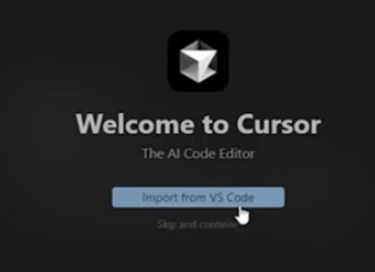

4.2 Opening Cursor
After installing Cursor, open the application. You will see the Cursor welcome screen with three main options:
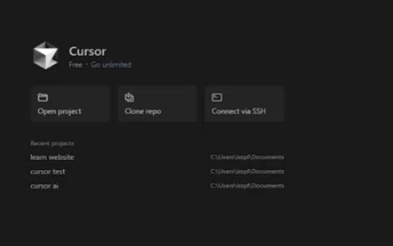

When I open the cursor there is 3 menu-
- Open project
- Clone repo
- Connect with SSH
1. Open Project 📂 (Open code already on your laptop.)
Purpose: Open an existing project or folder stored on your local system.
Example:
- You have a Python project in:
- D:\Projects\EmployeeManagement
- Click Open Project → Select the folder.
- Cursor loads all files and starts AI assistance.

2. Clone Repo 🔄 (Download code from GitHub/Azure DevOps.)
Purpose: Clone an existing project from a Git repository, such as GitHub, and open it in Cursor.
Example: Repository: https://github.com/arunlal/python-training.git
Steps - Click Clone Repo
- Paste the repository URL
- Choose a local folder
- Cursor downloads the code
Use Case: When the code is stored in a remote Git repository.

3. Connect with SSH 🌐 (Work directly on a remote server.)
Purpose: Connect to a remote server and work on code stored there.
Example:
Server: 10.10.10.100
User: ubuntu

Steps:
- Click Connect with SSH
- Enter server details
- Connect to the remote machine
- Edit and run code directly on the server
Use Case: Working on Linux servers, cloud VMs, or production environments without copying code locally.

For our hands-on session
We will use "Open Project" because we will create and work with our project locally on our system.

5th: Cursor AI vs Visual Studio Code
VS Code is primarily a code editor that can be extended with AI tools, while Cursor is an AI-first code editor designed around AI-assisted development.
